
Athletic Department
Athletic Director: Lamonte Curry
lcurry@marion.k12.sc.us
Cell #: (843)992-6349

Mullins High School
747 Milliers Rd.
Mullins, SC 29574

Varsity Football/ Soccer
Mullins High School

Visitor Information Sheet
- Parking:
  - Use school entrance on Millers Rd. Turn left onto Smith St. Entrance will be on the left before and after Gate/ Concession Building.
- Clear Bag Policy
  - Reminder- the clear bag policy is in effect for all sporting and large events in MCSD.
- Tickets:
  - Cash -$10.00
  - Debit/ Credit- $10.00 + Hometown Fees
  - Tickets will be available via: https://aucsathletics.hometown.com/events?ticketed=true

- Passes
  - SCHSL Passes are accepted (with Picture ID)

- Please contact MuHS Athletic Director with any additional questions or concerns

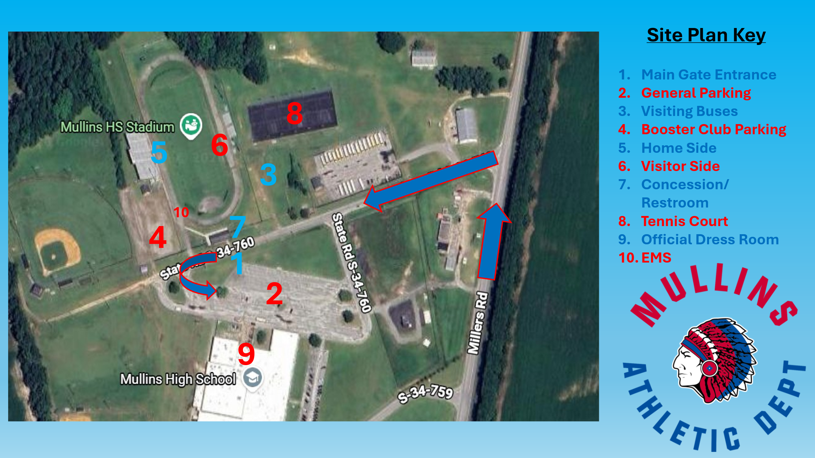
Clear Bag Policy

